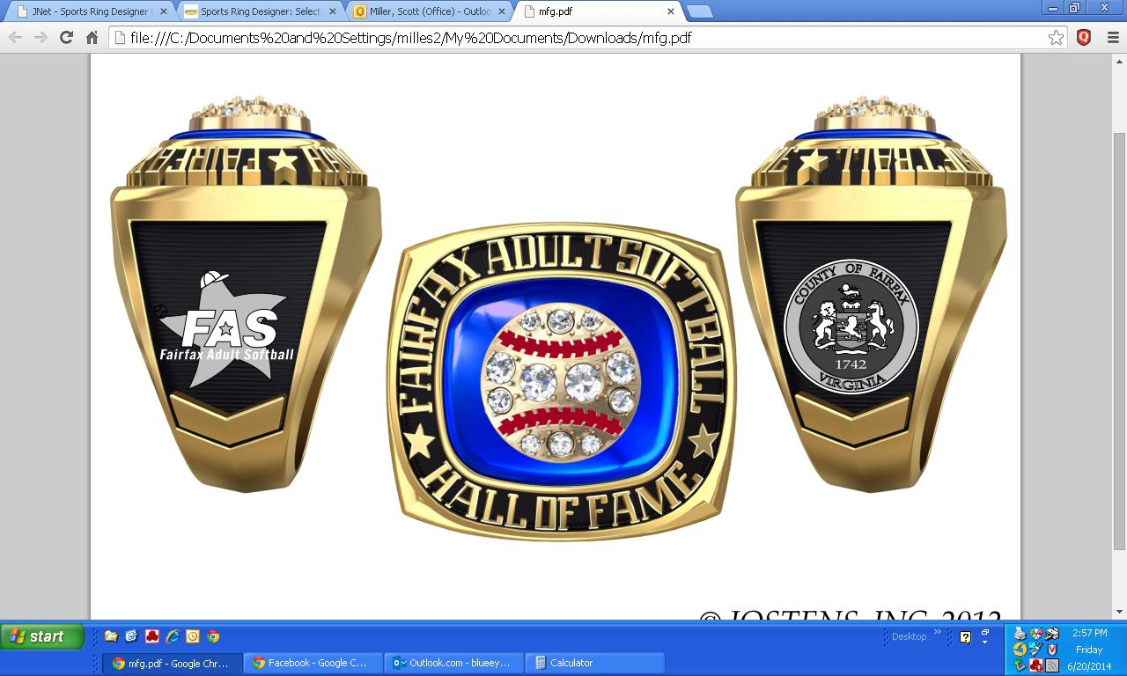

FAIRFAX ADULT SOFTBALL
HALL OF FAME

Jostens commitment to excellence begins with its National reputation for outstanding service and products. Each champion and championship team ring carries its on identity that sets it apart from any others. Jostens recognizes this and will provide a custom ring for this years inductees.

For your Hall of Fame ring, the following prices would be applicable:

Metal Choice:
Lustrium (silver) NO crest $ 227.00
Lustrium (silver) with softball crest $ 306.00
Yellow Lustrium (gold-plated) NO crest $ 259.00
Yellow Lustrium (gold-plated) with softball crest $ 338.00

Tax and shipping is included in the price of the ring.

All rings are mailed to the individual in 6-8 weeks.
Orders may be placed by calling (540) 891-4183 or emailing matthew.robertie@jostens.com. You will need your ring size and credit card #.

You choose the metal, stone color and whether you want the softball crest. You will also personalize side 1 of the ring with your name (first or last) and side 2 with the date of your induction. You may also include engraving of your full name inside the ring.

