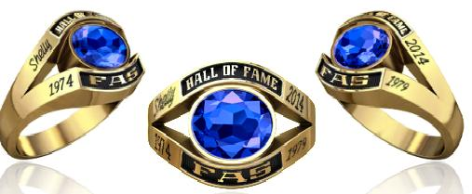

FAIRFAX ADULT SOFTBALL
HALL OF FAME

Jostens commitment to excellence begins with its National reputation for outstanding service and products. Each champion and championship team ring carries its on identity that sets it apart from any others. Jostens recognizes this and will provide a custom ring for this years inductees.

For your Hall of Fame ring, the following prices would be applicable:

Metal Choice:
Lustrium (silver) $ 160.00
Yellow Lustrium (gold-plated) $ 193.00

Tax and shipping is included in the price of the ring.

All rings are mailed to the individual in 6-8 weeks.
Orders may be placed by calling (540) 891-4183 or emailing matthew.robertie@jostens.com. You will need your ring size and credit card #.

You choose the metal and stone color. You will also personalize the four sides you’re your information (each area holds a maximum of 9 characters). You may also include engraving of your full name inside the ring (up to 30 characters).

